*EfficientNetB4 Model Observation and Analysis*

* *First Training Test*

| **Parameter** | **Value** |
| --- | --- |
| Learning Rate | 0.00001 |
| Epochs | 10 |
| Rotation Range | 40 |
| Width Shift Range | 0.4 |
| Height Shift Range | 0.4 |
| Shear Range | 0.3 |
| Zoom Range | 0.4 |
| Vertical Flip | True |

* *Result and Observation*

| **Epoch** | **Step** | **Time** | **Loss** | **Accuracy** | **Val Loss** | **Val Accuracy** |
| --- | --- | --- | --- | --- | --- | --- |
| 1 | 179/179 | 216s | 1.2683 | 0.4304 | 1.3655 | 0.3362 |
| 2 | 179/179 | 145s | 0.9244 | 0.6577 | 1.2519 | 0.3386 |
| 3 | 179/179 | 145s | 0.6511 | 0.7668 | 1.0321 | 0.5483 |
| 4 | 179/179 | 145s | 0.5333 | 0.7971 | 1.3233 | 0.3252 |

**Maximum Validation-Accuracy Obtained: 54.83%**

**Validation-Loss: 1.0321**

* *Second Training Test*

| **Parameter** | **Value** |
| --- | --- |
| Learning Rate | 0.0001 |
| Epochs | 30 |
| Rotation Range | 20 |
| Width Shift Range | 0.2 |
| Height Shift Range | 0.2 |
| Shear Range | 0.2 |
| Zoom Range | 0.2 |
| Vertical Flip | False |

* *Result and Observation*

| **Epoch** | **Step** | **Time** | **Loss** | **Accuracy** | **Val Loss** | **Val Accuracy** |
| --- | --- | --- | --- | --- | --- | --- |
| 1 | 179/179 | 216s | 0.4330 | 0.8381 | 1.5094 | 0.4030 |
| 2 | 179/179 | 144s | 0.1641 | 0.9425 | 1.8209 | 0.3197 |
| 3 | 179/179 | 146s | 0.1064 | 0.9637 | 2.3185 | 0.3370 |
| 4 | 179/179 | 144s | 0.0690 | 0.9772 | 3.5033 | 0.3181 |
| 5 | 179/179 | 145s | 0.0593 | 0.9814 | 0.6580 | 0.7439 |
| 6 | 179/179 | 149s | 0.0528 | 0.9820 | 1.2787 | 0.5734 |
| 7 | 179/179 | 145s | 0.0346 | 0.9895 | 3.1254 | 0.3409 |
| 8 | 179/179 | 145s | 0.0346 | 0.9884 | 0.3528 | 0.8775 |
| 9 | 179/179 | 144s | 0.0316 | 0.9904 | 2.1506 | 0.4580 |
| 10 | 179/179 | 145s | 0.0295 | 0.9895 | 1.6275 | 0.5020 |
| 11 | 179/179 | 145s | 0.0159 | 0.9946 | 2.1292 | 0.4996 |
| 12 | 179/179 | 145s | 0.0257 | 0.9916 | 6.0443 | 0.3559 |
| 13 | 179/179 | 145s | 0.0198 | 0.9940 | 0.4916 | 0.8523 |

**Maximum Validation-Accuracy Obtained: 87.75%**

**Validation-Loss: 0.3528**

* *Third Training Test*

| **Parameter** | **Value** |
| --- | --- |
| Learning Rate | 0.00001 |
| Epochs | 30 |
| Rotation Range | 20 |
| Width Shift Range | 0.2 |
| Height Shift Range | 0.2 |
| Shear Range | 0.2 |
| Zoom Range | 0.2 |
| Vertical Flip | False |
| **Checkpoint Included** | **Yes** |

* *Result and Observation*

| **Epoch** | **Step** | **Time** | **Loss** | **Accuracy** | **Val Loss** | **Val Accuracy** |
| --- | --- | --- | --- | --- | --- | --- |
| 1 | 179/179 | 218s | 1.1431 | 0.5464 | 1.3923 | 0.3134 |
| 2 | 179/179 | 150s | 0.6690 | 0.7873 | 1.3529 | 0.3260 |
| 3 | 179/179 | 152s | 0.4305 | 0.8562 | 0.8985 | 0.5797 |
| 4 | 179/179 | 150s | 0.3240 | 0.8924 | 0.7187 | 0.7164 |
| 5 | 179/179 | 153s | 0.2700 | 0.9047 | 0.5782 | 0.7958 |
| 6 | 179/179 | 144s | 0.2347 | 0.9161 | 1.5516 | 0.3708 |
| 7 | 179/179 | 151s | 0.1970 | 0.9306 | 0.5100 | 0.8154 |
| 8 | 179/179 | 145s | 0.1872 | 0.9357 | 0.7193 | 0.7258 |
| 9 | 179/179 | 145s | 0.1633 | 0.9425 | 0.8410 | 0.6096 |
| 10 | 179/179 | 156s | 0.1512 | 0.9455 | 0.3125 | 0.8940 |
| 11 | 179/179 | 156s | 0.1336 | 0.9559 | 0.2679 | 0.9144 |
| 12 | 179/179 | 145s | 0.1291 | 0.9541 | 0.4792 | 0.8044 |
| **13** | **179/179** | **156s** | **0.1099** | **0.9609** | **0.1809** | **0.9403** |
| 14 | 179/179 | 145s | 0.1160 | 0.9571 | 0.4956 | 0.7973 |
| 15 | 179/179 | 144s | 0.0977 | 0.9655 | 0.2211 | 0.9199 |
| 16 | 179/179 | 145s | 0.0986 | 0.9657 | 0.2903 | 0.8892 |
| 17 | 179/179 | 145s | 0.0852 | 0.9711 | 0.4203 | 0.8358 |
| 18 | 179/179 | 145s | 0.0896 | 0.9702 | 0.3545 | 0.8578 |
| ***Test*** | ***40/40*** | ***10s*** | ***0.1809*** | ***0.9403*** |  |  |

*\*Note: The Early Stopping Mechanism stopped the Model at 18/30 Epoche for the model*

**Maximum Validation-Accuracy Obtained: 94.03%**

**Validation-Loss: 0.1809**

* *Fourth Training Test*

| **Parameter** | **Value** |
| --- | --- |
| Epochs | 30 |
| Learning Rate | 0.0001 |
| ***Reduce LR Included*** | ***Yes*** |
| ***Reduce LR Details*** | ***monitor='val_loss', factor=0.2, patience=3, min_lr=1e-6*** |

* *Result and Observation*

| **Epoch** | **Train Loss** | **Train Accuracy** | **Val Loss** | **Val Accuracy** | **Learning Rate** |
| --- | --- | --- | --- | --- | --- |
| 1 | 1.6980 | 0.8367 | 2.6975 | 0.3181 | 1.0000e-04 |
| 2 | 1.3018 | 0.9445 | 2.4951 | 0.3181 | 1.0000e-04 |
| 3 | 1.1099 | 0.9650 | 1.5460 | 0.7502 | 1.0000e-04 |
| 4 | 0.9592 | 0.9769 | 2.6085 | 0.4619 | 1.0000e-04 |
| 5 | 0.8246 | 0.9807 | 4.5175 | 0.3221 | 1.0000e-04 |
| 6 | 0.7133 | 0.9811 | 0.8404 | 0.9293 | 1.0000e-04 |
| 7 | 0.5947 | 0.9870 | 4.1597 | 0.3551 | 1.0000e-04 |
| 8 | 0.5039 | 0.9900 | 2.6479 | 0.4297 | 1.0000e-04 |
| 9 | 0.4251 | 0.9912 | 0.7380 | 0.8845 | 1.0000e-04 |
| 10 | 0.3613 | 0.9888 | 3.6102 | 0.3480 | 1.0000e-04 |
| 11 | 0.2908 | 0.9947 | 3.1961 | 0.4234 | 1.0000e-04 |
| 12 | 0.2390 | 0.9958 | 1.1449 | 0.7298 | 1.0000e-04 |
| 13 | 0.2105 | 0.9954 | 0.4991 | 0.9002 | 2.0000e-05 |
| 14 | 0.1983 | 0.9965 | 0.2667 | 0.9709 | 2.0000e-05 |
| 15 | 0.1903 | 0.9965 | 0.3599 | 0.9419 | 2.0000e-05 |
| 16 | 0.1806 | 0.9970 | 0.3404 | 0.9411 | 2.0000e-05 |
| 17 | 0.1697 | 0.9974 | 0.1882 | 0.9890 | 2.0000e-05 |
| 18 | 0.1592 | 0.9977 | 0.2454 | 0.9670 | 2.0000e-05 |
| 19 | 0.1500 | 0.9974 | 0.4338 | 0.9010 | 2.0000e-05 |
| 20 | 0.1422 | 0.9975 | 1.1522 | 0.6826 | 2.0000e-05 |
| 21 | 0.1357 | 0.9979 | 0.1469 | 0.9945 | 4.0000e-06 |
| 22 | 0.1342 | 0.9984 | 0.1464 | 0.9937 | 4.0000e-06 |
| 23 | 0.1304 | 0.9982 | 0.1362 | 0.9969 | 4.0000e-06 |
| 24 | 0.1277 | 0.9989 | 0.1352 | 0.9961 | 4.0000e-06 |
| 25 | 0.1283 | 0.9984 | 0.1822 | 0.9796 | 4.0000e-06 |
| **26** | **0.1261** | **0.9981** | **0.1313** | **0.9976** | **4.0000e-06** |
| 27 | 0.1235 | 0.9981 | 0.1306 | 0.9961 | 4.0000e-06 |
| 28 | 0.1198 | 0.9988 | 0.1346 | 0.9945 | 4.0000e-06 |
| 29 | 0.1183 | 0.9984 | 0.1306 | 0.9953 | 4.0000e-06 |
| 30 | 0.1162 | 0.9981 | 0.1225 | 0.9969 | 4.0000e-06 |
| ***Test*** | ***0.1313*** | ***0.9976*** | - | - | - |

**Maximum Validation-Accuracy Obtained: 99.76%**

**Validation-Loss: 0.1313**

* *Intuition or Insights*

**Learning Rate**: The change in learning rate from 0.0001 to 0.00001 can have a profound impact on the training dynamics. The lower learning rate allows for more gradual updates to the model's weights, potentially leading to better convergence.

**ReduceLROnPlateau Callback**: This callback helps in adjusting the learning rate dynamically based on the validation loss. If the validation loss plateaus, the learning rate is reduced by a factor (in this case, 0.2). This can help the model converge better by reducing the learning rate when necessary.

**Model Initialization and Randomness**: Neural networks are initialized with random weights, and the training process involves stochastic processes (e.g., shuffling of data, dropout). These random elements can lead to different training outcomes even with the same model and data.

**Validation Performance**: The new training results show better validation performance consistently across epochs. This indicates that the model is generalizing better to the validation data, which likely translates to better test performance as well.

* *Screenshot of Output:*

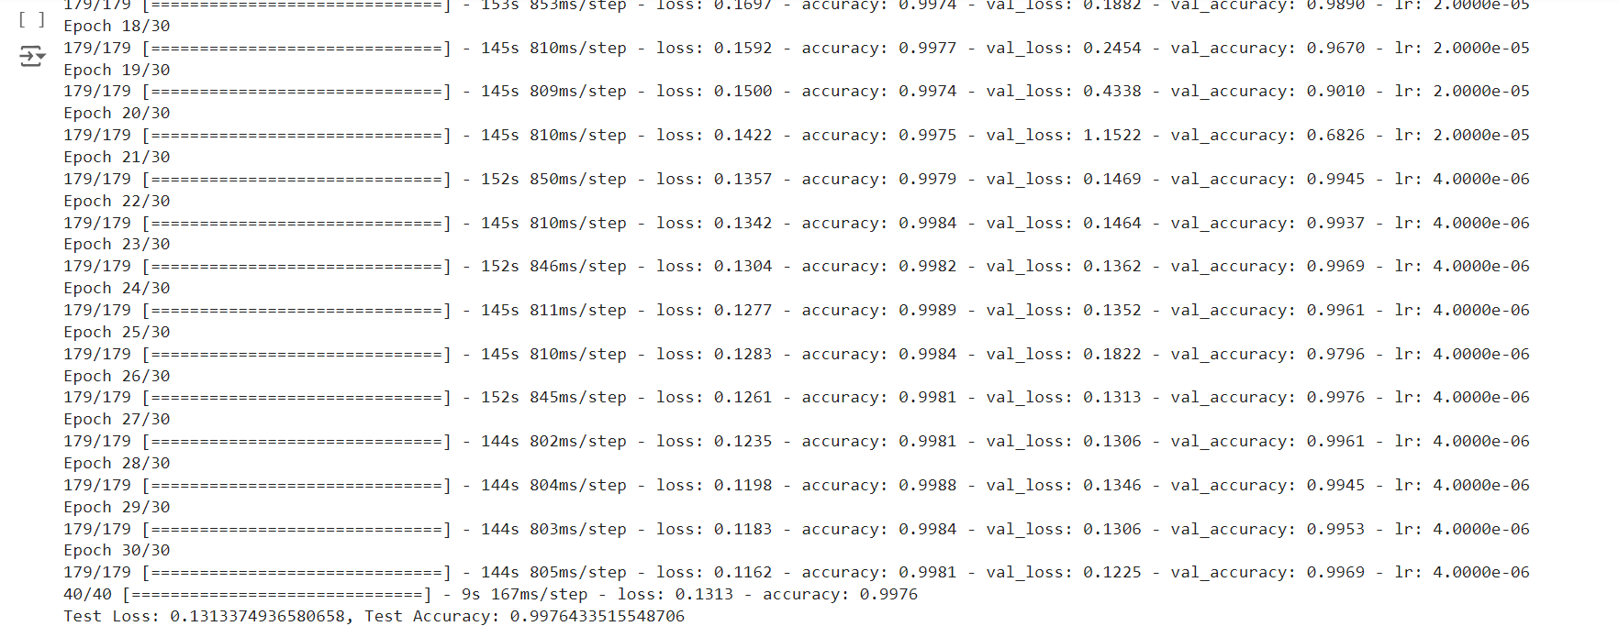

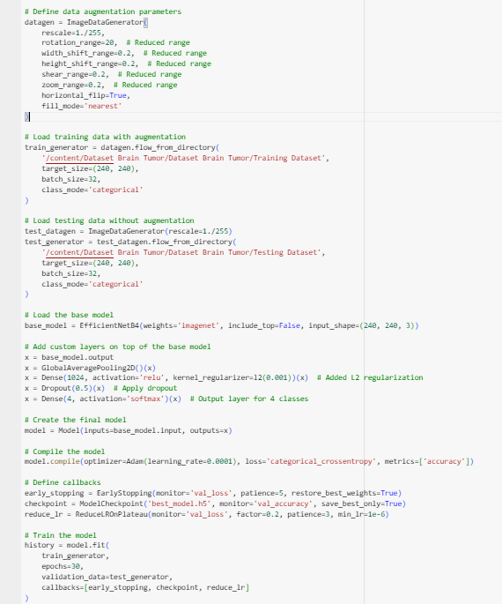

* *Fifth Training Test:*

Performed a Cross-Validation Test for Fourth Training Test (Accuracy of 99.76%) and also included other metrics like Fscore, Recall, Precision, AUC to get a better Picture

(Rest Parameters remains same)

* *Result and Observation*

| **Epoch** | **Training Loss** | **Training Accuracy** | **Validation Loss** | **Validation Accuracy** | **Learning Rate** |
| --- | --- | --- | --- | --- | --- |
| 1 | 1.7054 | 0.8320 | 3.4837 | 0.3181 | 1.0000e-04 |
| 2 | 1.2887 | 0.9441 | 4.0600 | 0.3181 | 1.0000e-04 |
| 3 | 1.1112 | 0.9620 | 2.2104 | 0.4941 | 1.0000e-04 |
| 4 | 0.9447 | 0.9762 | 2.3074 | 0.5609 | 1.0000e-04 |
| 5 | 0.8225 | 0.9783 | 3.3032 | 0.3896 | 1.0000e-04 |
| 6 | 0.6981 | 0.9832 | 3.3179 | 0.4375 | 1.0000e-04 |
| 7 | 0.6169 | 0.9911 | 0.9634 | 0.8445 | 2.0000e-05 |
| 8 | 0.5903 | 0.9933 | 0.9736 | 0.8460 | 2.0000e-05 |
| 9 | 0.5658 | 0.9932 | 1.8827 | 0.6316 | 2.0000e-05 |
| 10 | 0.5388 | 0.9947 | 0.5707 | 0.9811 | 2.0000e-05 |
| 11 | 0.5188 | 0.9937 | 0.6859 | 0.9332 | 2.0000e-05 |
| 12 | 0.4969 | 0.9942 | 1.7978 | 0.6402 | 2.0000e-05 |
| 13 | 0.4740 | 0.9944 | 1.9290 | 0.6339 | 2.0000e-05 |
| 14 | 0.4568 | 0.9953 | 0.6024 | 0.9466 | 4.0000e-06 |
| 15 | 0.4489 | 0.9960 | 0.4563 | 0.9921 | 4.0000e-06 |
| 16 | 0.4456 | 0.9960 | 0.4532 | 0.9929 | 4.0000e-06 |
| 17 | 0.4383 | 0.9960 | 0.4448 | 0.9953 | 4.0000e-06 |
| 18 | 0.4344 | 0.9953 | 0.4384 | 0.9953 | 4.0000e-06 |
| 19 | 0.4275 | 0.9960 | 0.4509 | 0.9882 | 4.0000e-06 |
| 20 | 0.4221 | 0.9961 | 0.5025 | 0.9654 | 4.0000e-06 |
| 21 | 0.4145 | 0.9967 | 0.4322 | 0.9914 | 4.0000e-06 |
| 22 | 0.4123 | 0.9958 | 0.4232 | 0.9906 | 4.0000e-06 |
| 23 | 0.4044 | 0.9963 | 0.4977 | 0.9576 | 4.0000e-06 |
| 24 | 0.3961 | 0.9965 | 0.4400 | 0.9835 | 4.0000e-06 |
| 25 | 0.3895 | 0.9970 | 0.5116 | 0.9513 | 4.0000e-06 |
| **26** | **0.3872** | **0.9968** | **0.3910** | **0.9969** | **1.0000e-06** |
| 27 | 0.3904 | 0.9944 | 0.3915 | 0.9961 | 1.0000e-06 |
| **28** | **0.3811** | **0.9972** | **0.3898** | **0.9969** | **1.0000e-06** |
| 29 | 0.3823 | 0.9963 | 0.3871 | 0.9961 | 1.0000e-06 |
| 30 | 0.3809 | 0.9963 | 0.3856 | 0.9953 | 1.0000e-06 |

* *Classification Report:*

| **Class** | **Precision** | **Recall** | **F1-Score** | **Support** |
| --- | --- | --- | --- | --- |
| Glioma | 1.00 | 1.00 | 1.00 | 262 |
| Meningioma | 0.99 | 0.99 | 0.99 | 306 |
| No Tumor | 1.00 | 1.00 | 1.00 | 405 |
| Pituitary | 0.99 | 1.00 | 1.00 | 300 |
| **Accuracy** | **1.00** | **1.00** | **1.00** | **1273** |
| Macro Avg | 1.00 | 1.00 | 1.00 | 1273 |
| Weighted Avg | 1.00 | 1.00 | 1.00 | 1273 |

* *Test Results:*

| **Metric** | **Value** |
| --- | --- |
| Test Loss | 0.3910 |
| Test Accuracy | 0.9969 |

* *AUC Score per Class Results:*

| **Class** | **AUC Score** |
| --- | --- |
| Glioma | 0.9999886742020975 |
| Meningioma | 0.9995809423390176 |
| No Tumor | 1.0 |
| Pituitary | 0.9996848235697157 |

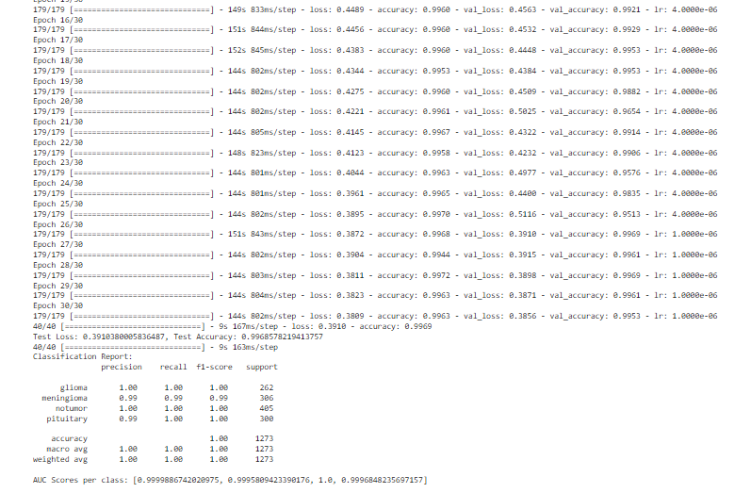

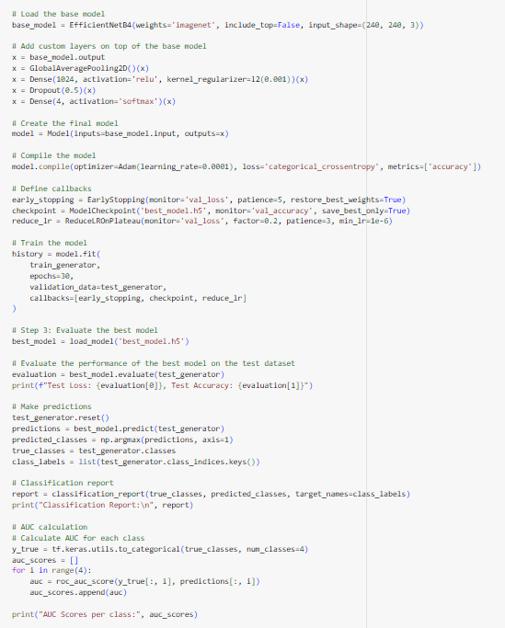

| **Epoch** | **Training Accuracy** | **Training Loss** | **Validation Accuracy** | **Validation Loss** | **Learning Rate** |
| --- | --- | --- | --- | --- | --- |
| 1 | 0.6859 | 2.0873 | 0.7176 | 2.0085 | 1.0000e-04 |
| 2 | 0.9482 | 1.3246 | 0.3181 | 3.5709 | 1.0000e-04 |
| 3 | 0.9635 | 1.1529 | 0.3433 | 2.6559 | 1.0000e-04 |
| 4 | 0.9732 | 0.9937 | 0.3551 | 3.0487 | 1.0000e-04 |
| 5 | 0.9732 | 0.8685 | 0.5122 | 2.4755 | 1.0000e-04 |
| 6 | 0.9851 | 0.7359 | 0.5452 | 2.4463 | 1.0000e-04 |
| 7 | 0.9892 | 0.6195 | 0.7879 | 1.1109 | 1.0000e-04 |
| 8 | 0.9904 | 0.5293 | 0.3959 | 3.4433 | 1.0000e-04 |
| 9 | 0.9916 | 0.4473 | 0.5986 | 1.5523 | 1.0000e-04 |
| 10 | 0.9891 | 0.3785 | 0.3166 | 2.9753 | 1.0000e-04 |
| 11 | 0.9931 | 0.3203 | 0.9592 | 0.4228 | 2.0000e-05 |
| 12 | 0.9950 | 0.3011 | 0.8476 | 0.7184 | 2.0000e-05 |
| 13 | 0.9980 | 0.2842 | 0.9254 | 0.4897 | 2.0000e-05 |
| 14 | 0.9946 | 0.2784 | 0.6457 | 1.5027 | 2.0000e-05 |
| 15 | 0.9955 | 0.2648 | 0.9701 | 0.3433 | 4.0000e-06 |
| 16 | 0.9973 | 0.2657 | 0.9976 | 0.2636 | 4.0000e-06 |
| 17 | 0.9973 | 0.2568 | 0.9961 | 0.2651 | 4.0000e-06 |
| 18 | 0.9975 | 0.2519 | 0.9874 | 0.2742 | 4.0000e-06 |
| 19 | 0.9976 | 0.2517 | 0.9882 | 0.2676 | 4.0000e-06 |
| 20 | 0.9976 | 0.2509 | 0.9969 | 0.2540 | 1.0000e-06 |
| 21 | 0.9982 | 0.2450 | 0.9961 | 0.2518 | 1.0000e-06 |
| 22 | 0.9968 | 0.2467 | 0.9961 | 0.2511 | 1.0000e-06 |
| 23 | 0.9991 | 0.2421 | 0.9961 | 0.2520 | 1.0000e-06 |
| 24 | 0.9961 | 0.2454 | 0.9976 | 0.2483 | 1.0000e-06 |
| 25 | 0.9983 | 0.2429 | 0.9976 | 0.2465 | 1.0000e-06 |
| 26 | 0.9969 | 0.2432 | 0.9976 | 0.2452 | 1.0000e-06 |
| 27 | 0.9979 | 0.2391 | 0.9976 | 0.2459 | 1.0000e-06 |
| 28 | 0.9968 | 0.2419 | 0.9961 | 0.2463 | 1.0000e-06 |
| 29 | 0.9974 | 0.2368 | 0.9961 | 0.2449 | 1.0000e-06 |
| 30 | 0.9979 | 0.2365 | 0.9976 | 0.2414 | 1.0000e-06 |